COSC 2P91 – Assignment 4 (Mini-Project 2)
Matt Laidman
5199807 (ml12ef)
April 15, 2015

Table of Contents
Scene File Formatting 1
Sample Execution 2
Sample Images 4
SourceCode 5

Scene File Formatting
matt@matt-gnome:~/Desktop/A4$ cat SampleScene.txt
2
200 200 300 100 0.5 0.0 1.0 1 0
300 300 500 100 0.0 0.1 0.5 1 1
1
150 250 0 0.5 0.5 0.5
0.2 0.2 0.2
matt@matt-gnome:~/Desktop/A4$

The first line in the file is the number of spheres.
The spheres and their materials follow. They have the following format:

<X> <Y> <Z> <Radius> <R> <G> <B> <Diffuse> <Specular>

Diffuse and specular are 1 or 0 for on or off respectively.
The next line in the file is the number of lights, followed by the lights.
A light has the following format:

<X> <Y> <Z> <R> <G> <B>

The final line is the ambient lighting, with the following format:

<R> <G> <B>

Sample Execution
matt@matt-gnome:~/Desktop/A4$ ./demo.sh

Scene files must be in the appropriate subfolders.
See sample scene file, SampleScene.txt, or documentation.
Images are saved to their respective subfolders.

Select file to run:

1. Colours test (Part One)
2. Sillhouette (Part B)
3. Full Scene (Part The Third)
0. Quit

1

1. Create Colours
0. Quit

1

Enter width: 500
Enter height: 500
# of threads: 8
Output Filename: PartOneSample.ppm

1. Create Colours
0. Quit

0

1. Colours test (Part One)
2. Sillhouette (Part B)
3. Full Scene (Part The Third)
0. Quit

2

1. Make Sillhouette
0. Quit

1

Enter width: 500
Enter height: 500
Enter scene file name: SampleScene.txt
# of threads: 8
Output Filename: PartBSample.ppm

1. Make Sillhouette
0. Quit

0

1. Colours test (Part One)
2. Sillhouette (Part B)
3. Full Scene (Part The Third)
0. Quit

3

1. Make Scene
0. Quit

1

Enter width: 500
Enter height: 500
Enter scene file name: SampleScene.txt
# of threads: 8
Output Filename: PartTheThirdSample.ppm

1. Make Scene
0. Quit

0

1. Colours test (Part One)
2. Sillhouette (Part B)
3. Full Scene (Part The Third)
0. Quit

0
matt@matt-gnome:~/Desktop/A4$

Sample Images
Sample images (scaled to fit on page) created from SampleScene.txt. Also included as PNGs in electronic submission.

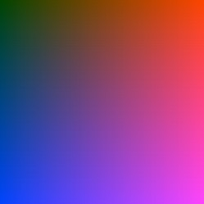

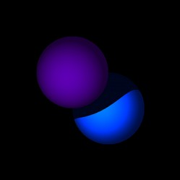
SourceCode

